Task:1 Write a short scenario where a user tries to access a private WiFi network (like at a campus or airport) and describe how each of the three AAA functions—Authentication, Authorization, and Accounting—would apply step by step in this situation.
A college student, walks into the campus library with his laptop. He needs to access the internet to research a project. He opens his Wi-Fi settings and connects to the private secure network named "Campus-Secure."
Authentication
Rohan types in his university username (rohan.s@univ.edu) and his unique password. The wireless access point passes these credentials to the university’s central AAA server. The server checks its database to see if the username exists and if the password matches. If they match, the system confirms, "Yes, this is truly Rohan," and lets him past the digital front door.
Authorization
The AAA server identifies Rohan's account profile as a "Student." Based on this profile, the network automatically applies specific rules to his session. He is granted access to the general internet and student assignment portals. However, the system explicitly blocks him from accessing staff payroll systems, internal server configuration pages, and high-bandwidth gaming ports. It may also restrict his maximum download speed to 20 Mbps to save bandwidth for others.
Accounting
The AAA server starts a digital stopwatch the exact moment Rohan logs in and begins tracking his data usage. The server logs the timestamp of his login (e.g., 10:15 AM), his laptop's physical MAC address, the IP address assigned to him, and the amount of data he transfers. When Rohan closes his laptop and leaves the library at 12:30 PM, the server records his logout time and notes that he consumed 450 MB of data. This log is saved so network administrators can audit who was on the network if a security breach occurs later.

Task:2 Create a table comparing at least two different AAA deployment models (such as centralized vs distributed), listing three advantages and three disadvantages of each for a company like Zomato that handles sensitive user data.
Centralized AAA Model | Distributed AAA Model
All login requests from every region go to a single, unified database cluster. | Independent authentication servers are placed locally inside distinct regional hubs or data centers.
Unified Security Policies: Easier to enforce strict, company-wide compliance rules on sensitive customer credit card and profile data from a single point. | Blazing-Fast Performance: Drastically reduces login and processing latency for delivery riders and local restaurants making requests nearby.
Simplified Auditing: All accounting logs are written to one central location, allowing instant tracking of security breaches or fraud across the whole app. | High Fault Tolerance: If a regional server fails or goes offline, it only impacts that specific city, leaving the rest of the nationwide app functional
Lower Management Overhead: Security updates, password changes, and patch management only need to be applied to the central cluster. | Reduced WAN Dependency: Local delivery nodes can still authenticate users and log deliveries locally during a major backbone internet outage.
Single Point of Failure: If the central AAA cluster crashes or loses power, Zomato’s entire platform goes down nationwide instantly. | Complex Policy Syncing: Highly difficult to guarantee that critical security patches or data updates are perfectly identical across every regional hub in real time.
Increased WAN Latency: A delivery partner in a remote city experiences slower response times because their credentials must travel across the country to verify. | Higher Hardware & License Costs: Requires buying, deploying, maintaining, and licensing separate server hardware in multiple geographic locations.
High Network Bottlenecks: During peak food-ordering hours (like dinner rushes), millions of simultaneous requests can easily overwhelm a single central gateway. | Scattered Audit Logs: Tracking fraud or data leaks requires aggregating logs from dozens of regional servers, slowing down security investigation teams.

Task 3: Draw a simple network diagram (can be hand-drawn and photographed) showing how AAA servers are integrated into a typical enterprise network for user access control, labelling where Authentication, Authorization, and Accounting processes happen.
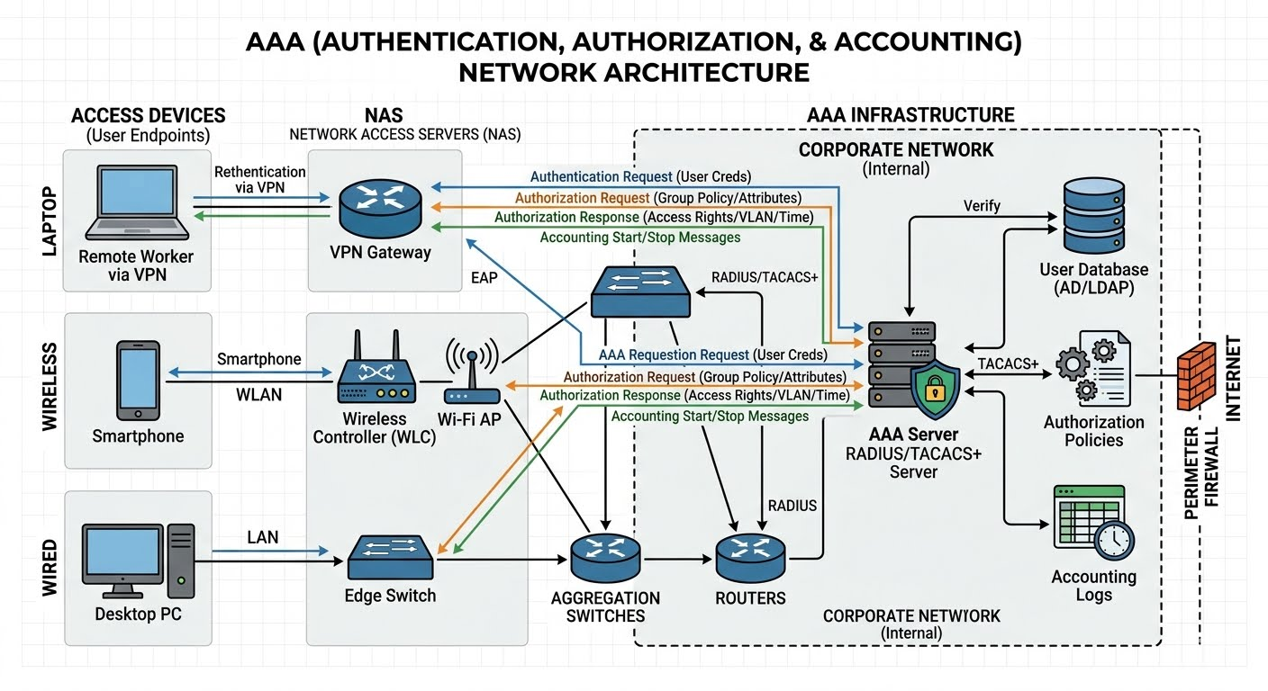
Authentication (The User & AAA Server): This process begins at the user’s end device (Laptop) and finishes inside the Central AAA Server. The switch acts as a transparent middleman, passing the user's password or certificate straight to the AAA server database to confirm the user's identity.
Authorization (The Network Switch / NAS): While the policy rules are stored on the AAA Server, enforcement happens directly on the Network Switch port or edge router. Once the AAA server tells the switch what the user is allowed to do, the switch actively applies the specific VLAN, speed limits, and firewall Access Control Lists (ACLs) to that user's physical connection.
Accounting (The Switch streaming to AAA Logs): This is a continuous process managed by the Network Switch while the user is online. The switch monitors the active connection, tallies up the bytes transferred, and pipes this raw data back into the AAA Server's logging database for continuous session audits.

Task 4: Pick any app you use daily (Instagram, Paytm, or Flipkart) and write a paragraph explaining how AAA concepts could be applied to secure user logins and actions within that app. Think about what happens when you log in, what features you are allowed to use, and how your actions might be tracked for security or billing.
Authentication
Authentication occurs the moment you open the app; Paytm verifies your identity using a multi-factor approach, requiring your registered mobile number, an account password, and a biometric check like your fingerprint or face scan.
Multi-Factor Challenges: Paytm uses a combination of factors to authenticate your session. It requires something you know (your secret PIN or password) and something you are (your physical fingerprint or facial biometrics).
Device Binding: The system also binds your profile to your physical hardware. It sends a silent SMS verification token from your phone to ensure that the SIM card registered to the account is physically inside the device you are holding. If someone steals your password but tries to log in from a different smartphone, Paytm detects the device change and blocks entry.
Authorization
Authorization takes over immediately after you are logged in, determining your specific access privileges based on your account verification level. For example, if you have completed full KYC (Know Your Customer) requirements, the system authorizes you to send up to ₹1,000,000 per day, whereas an unverified wallet profile might be restricted to a tight ₹10,000 monthly limit and blocked from bank-to-bank wire transfers.
KYC Tier Enforcement: If you have complete Full KYC verification (linked to government databases like Aadhaar or PAN), the platform authorizes your profile to process heavy transactions, up to ₹1,00,000 or more per day via UPI. If your profile is a Minimum KYC account, the system automatically revokes your privilege to transfer funds to external bank accounts and caps your monthly digital wallet balance at ₹10,000.
Role-Based Features: The interface physically adapts based on permissions. A standard consumer profile is only authorized to use buyer features like paying utility bills or shopping. A merchant profile receives extended authorization to generate business dynamic QR codes, access point-of-sale settlement tools, and view revenue analytics dashboards.

Accounting
Accounting constantly works behind the scenes as a digital ledger, meticulously tracking and timestamping every single action you take, such as the exact second you scanned a merchant's QR code, the precise geographic location of the shop, the unique transaction ID generated, and the monetary amount debited. This continuous logging serves as an audit trail to automatically flag fraudulent activity and ensure flawless financial dispute resolution.
The Transaction Ledger: The moment you scan a vendor's QR code and confirm a payment, the accounting engine permanently records a structured telemetry entry. This entry catalogs the exact timestamp down to the millisecond, your precise GPS coordinates, your active IP address, the merchant’s unique ID, and a generated transaction hash.
Security and Fraud Prevention: These immutable logs do more than populate your passbook; they are fed directly into real-time machine learning fraud engines. If the accounting logs show that you just bought coffee in Ahmedabad, and three minutes later your account attempts expensive electronics purchase from an IP address in London, the system flags the geographical impossibility and locks your wallet to prevent financial theft.
Task 5: Use ChatGPT or any AI tool to generate a sample AAA policy for a college WiFi network that restricts access to students only, allows certain websites, and logs all access attempts. Paste the generated policy and briefly explain how each AAA function is addressed.

[AUTHENTICATION_MODULE]
Auth_Method = "IEEE 802.1X / EAP-PEAP (MSCHAPv2)"
User_Directory = "Campus_Active_Directory_LDAP"
Allowed_User_OU = "OU=Students,DC=campus,DC=edu"
Max_Login_Sessions_Per_User = 2
Failed_Attempt_Lockout = 5_Attempts
Lockout_Duration = 30_Minutes

[AUTHORIZATION_MODULE]
Default_Access_Action = "DENY_ALL"
Assigned_VLAN = 40 (Student_Isolated_Network)
# Content Filtering & Web Whitelist
Permitted_Web_Categories = ["Education", "Academic_Research", "Search_Engines", "University_Services"]
Explicitly_Allowed_Domains = [
"*.wikipedia.org",
"://google.com",
"*.canvaslms.com",
"github.com"]
Blocked_Web_Categories = ["Online_Gaming", "Streaming_Entertainment", "Adult_Content", "P2P_Torrents"]
# Quality of Service (QoS) Constraints
Max_Downstream_Per_User = 20_Mbps
Max_Upstream_Per_User = 5_Mbps
Idle_Timeout = 60_Minutes

[ACCOUNTING_MODULE]
Log_Storage_Target = "syslog://log-collector.campus.edu:514"
Log_Format_Standard = "W3C_Extended_Log_Format"
Streamed_Telemetry_Data = [
"User_ID",
"Client_MAC_Address",
"Assigned_IP_Address",
"Session_Start_Time",
"Session_End_Time",
"Total_Bytes_Transferred",
"Blocked_URL_Violation_Attempts"
]
Log_Retention_Period = 180_Days
How Each AAA Function is Addressed
Authentication: This is explicitly enforced under the [AUTHENTICATION_MODULE]. The network uses the 802.1X EAP-PEAP standard to force a login screen on user devices. The system cross-references credentials directly against the Campus Active Directory database, explicitly restricting entry to accounts located within the student Organizational Unit (OU=Students). Anyone else, including unauthorized guests or faculty trying to use this specific SSID, is completely blocked at the front door.
Authorization: This is managed by the parameters within the [AUTHORIZATION_MODULE]. Once a student is authenticated, they do not get free-reign internet access. The policy forces a default DENY_ALL rule, meaning everything is blocked except for the specific whitelist domains (like Wikipedia and Canvas) and approved educational categories. Furthermore, it automatically places the student into an isolated network segment (VLAN 40) and throttles their connection speed to 20 Mbps to preserve school bandwidth.
Accounting: This is continuously handled by the [ACCOUNTING_MODULE] while the student stays online. The wireless system monitors the active connection and continuously streams structured data logs to a centralized syslog storage server. It records exactly who logged in, their physical machine address (MAC), how much data they downloaded, when they logged off, and any attempts to bypass the web filter. These logs are securely archived for 180 days for security auditing and tracking purposes.

